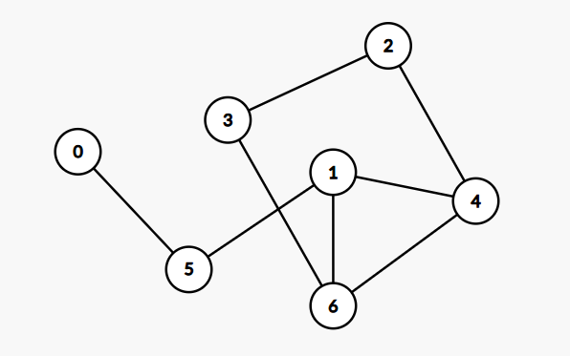

1. Find out what is the shortest distance between 0 to 3 using BFS.
2. Print the shortest path between 0 to 2 using BFS.